William Fan

Aug 10th 2025

Prof. Lemma

Lab Objective:  
 The objective of this lab is to install and configure a free VPN client using OpenVPN, connect to a remote VPN server, and verify the secure connection. I was able to establish VPN connection via credentials from NordVPN on openVPN software. This process demonstrates the ability to protect network communications by encrypting internet traffic and masking the client’s IP address.

Screenshot 1:

This screenshot shows the manual input of NordVPN service credentials (username and password) into the OpenVPN client after importing the .ovpn configuration file. These credentials authenticate the client to the VPN server and are necessary to establish a secure tunnel connection.

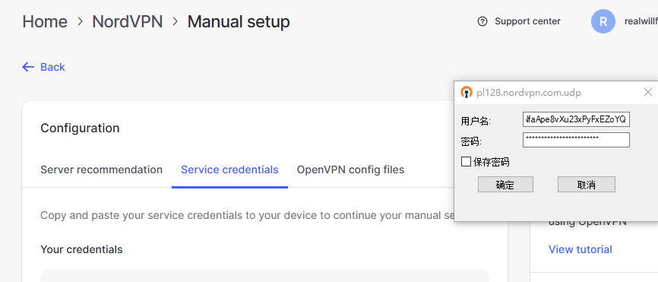  
Screenshot 2:

This screenshot displays the OpenVPN connection log indicating a successful connection to the server. The log confirms the assigning a private VPN IP address (10.100.0.2) and shows that route additions were completed.

